Blood Donation System

By

Amar Ippili

Zackaria Mufti

Venkata Anil Kumar Thota

Business Benefits and Goals:

The number of persons who need blood are increasing in large number day by day. To help people who need blood, Online Blood Donation system can be used effectively for getting the details of blood donors having the same blood group and within the same city. With the help of Online Blood Donation system people who are having the thought of donating blood gets registered in Website giving his total details.

Our goal to develop a web-based system to manage blood requisition within the blood supply chain. The system is designed to overcome the drawbacks of existing system problem. The main objective is to improve the efficiency of data communication within the supply chain to reduce response time for each blood demand request. We also focused on managing blood inventory at blood bank effectively. The results have shown that the proposed system helps enhancing the communication among blood partners within the supply chain network. The recipient can get blood in emergency case also.

Advantages of the Proposed System:

* The people in need of blood can search for the donors by giving their blood group and pincode.
* It is very flexible and user friendly.
* The person’s time and work are reduced which very much prevails in the present system.
* Easy and Helpful.
* The people are not limited to receive or provide services in working hours of the branch only; it is serviced 24 hours a day, 7 days of week and 365 days of the year

Key Features:

Online Blood Bank site is available to everyone easily. A person who likes to donate blood gives his entire details i.e., fill in the registration form and can create a username with a password by which he can modify his details if at all there are any changes in his information given before.

The present project elucidates the following features.

* Registering the Donors
* Modification of Donor Information
* Registering the Patients
* Modification of Patient Information
* Searching a Donor
* Contact US form for both Donors and Blood Seekers.

The persons who like to donate blood registers in site as well as he can modify the details if necessary, giving the Login Id and Password. The persons in need of blood searches for the persons having the same blood group and within the city. If he found donor in his city, he gets the total details of the donor. Also, the purpose for which the patients are seeking for blood is also stored in the Database, this will help for Analysis purpose.

Business Requirements:

Blood bank has a major task to collect blood from donors, monitor blood quality and supply, and distribute blood and blood components to hospitals within the network. Blood distribution is an important activity within this blood supply chain. If the blood bank can deliver blood supply to its respective demand in a timely manner, patients' lives will be saved. But nowadays, many regional blood banks confront with ineffective communication channel and insufficient information to fulfill its obligation. Thus, this leads to an inaccurate blood distribution and a waste of time, which can be harmful to patients with critical conditions. Business need an system where they can overcome the below Problems.

Problems with conventional blood bank system :

1. Lack of immediate retrievals: -The information is very difficult to retrieve and to find information like- E.g. - To find out about the donor’s history, the user must go through various registers. This results in inconvenience and wastage of time.

2. Searching required Blood group and donor is tedious job.

This system is proposed to provide online storage/ updating and retrieval facility. Online Donation System promises very less or no paper work and provides help to donor and blood recipients. In this system everything is stored electronically so very less amount of paper work is required and information can be retrieved very easily without searching here and there into registers.

Infrastructure:

Tools and Technologies:

* HTML
* CSS
* Java Script
* Tomcat
* MySQL
* Tableau

Hardware Configuration:

Processor : Core i5 8th Generation

RAM : 8 GB

Hard Disk Drive : 1 GB

Flow Diagram:

The Web Flow of our website is better understood by looking at the below diagram.

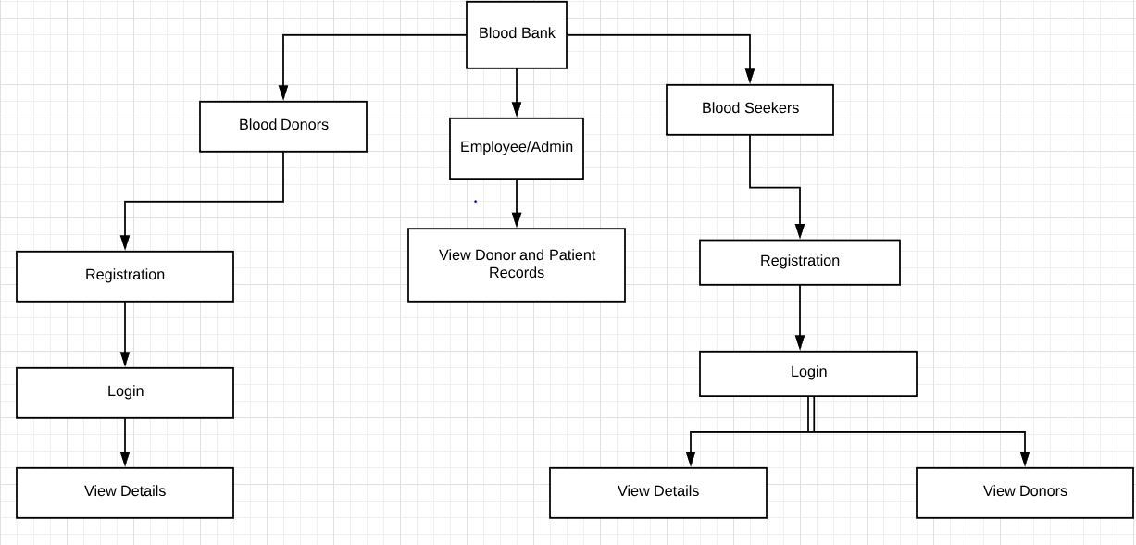

ERD:

An ERD (Entity Relationship Diagram) is a data model describing how entities relate to one another. The Key Elements in the ERD are Entities, Relationships and Attributes. In our ER diagram we have 4 Entities. The relationships between all the entities will be one to one relationship. You can find these details in the Below ER diagram.

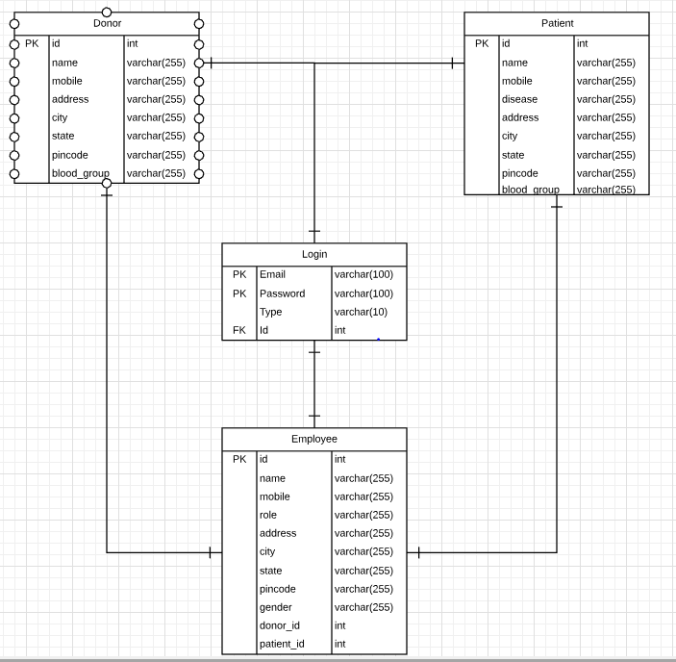

In login table Email and password are Primary keys and Id is Foreign Key. Username and password of Donor, Patient and Employee gets stored in the Login table. The “Type” attribute in the will decide whether the user is Donor/Patient/Employee. Donor and Patient tables will store all the donor and patient details respectively. Patient table will have an extra attribute called “Disease”. Patient should enter for what purpose he needs Blood. Employee table will also store donor and patient id.

Database Design and Results:

We created tables maintaining the referential integrity. We have our data in the form CSV (Comma Separated Values) file. Using the MySQL Workbench, we loaded the CSV file in to the respective tables. We ran different queries and retrieved the data from the MySQL Database some of the queries are explained below and few others can be found in SQL file which is attached along with this Document.

Query1: - Count of Blood Donors for a Zip Code displayed in Descending order.

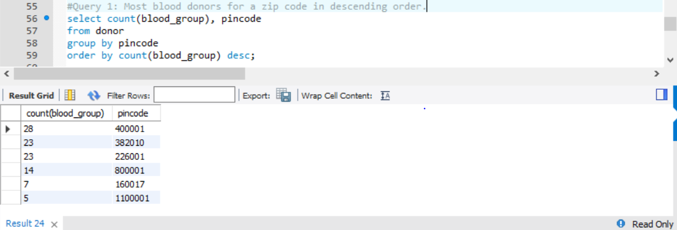

Query2: - Number of Donors available for Each Blood Group.  
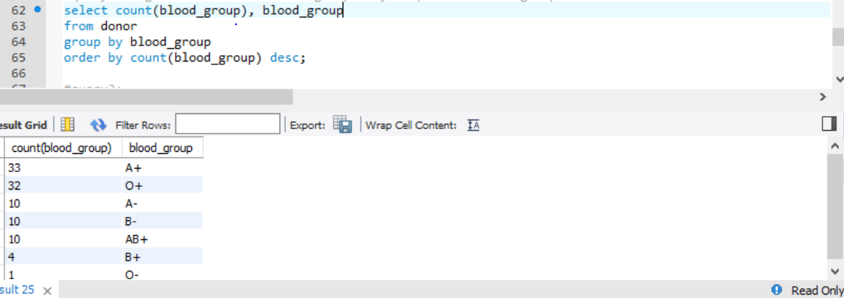

Query3: - Number of Blood Donors grouped by Blood group for Each Pincode .

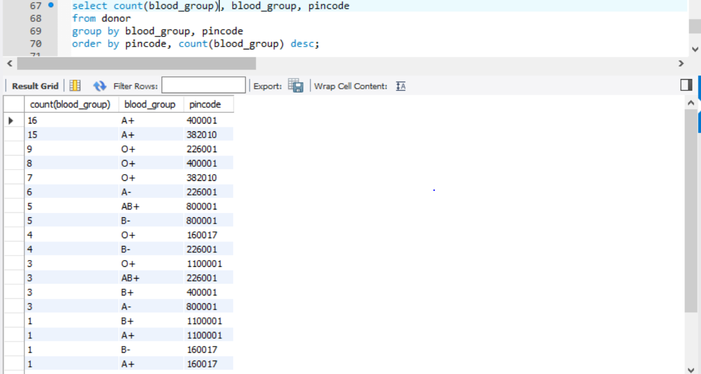

Query 4: - Count of patients for Each Pincode.

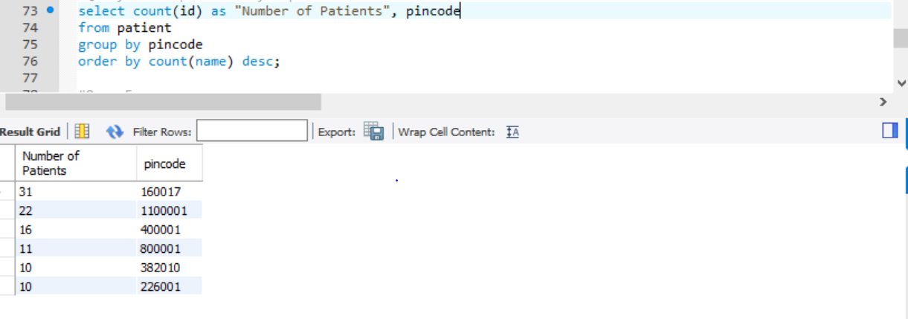

Query 5: - Count of Patients for Each Disease.

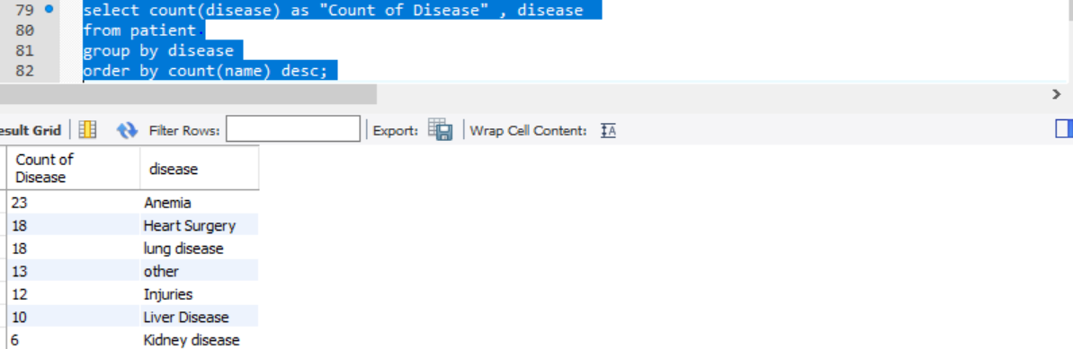

User Interface:

This section includes explanation of all the technologies used for front end designing and also few screenshots of the User Interface.

Html:

HTML stands for HyperText Markup Language. "Markup language" means that, rather than using a programming language to perform functions, HTML uses tags to identify different types of content and the purposes they each serve to the webpage.

HTML is at the core of every web page, regardless the complexity of a site or number of technologies involved. It's an essential skill for any web professional. It's the starting point for anyone learning how to create content for the web. And, luckily for us, it's surprisingly easy to learn. We used HTML to design the basic structure of sites which is enhanced and modified by other technologies like CSS and Java Script.

CSS:

CSS stands for Cascading Style Sheets. This programming language dictates how the HTML elements of a website should appear on the frontend of the page. CSS is designed to enable the separation of presentation and content, including layout, colors, and fonts.

Java Server Pages:

Java Server Pages (JSP) is a technology that helps software developers create dynamically generated web pages based on HTML, XML, or other document types. JSP is like PHP and ASP, but it uses the Java programming language.

To deploy and run Java Server Pages, a compatible web server with a servlet container, such as Apache Tomcat or Jetty, is required. We used Tomcat version 7 for our Project.

Below are some of the Screenshots for the UI.

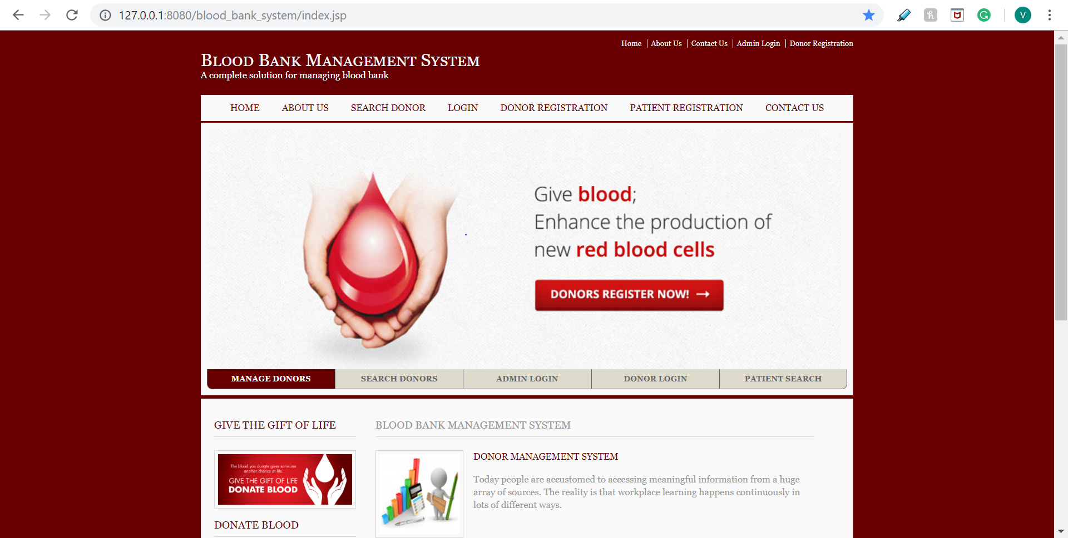

Fig: Index page of the Website

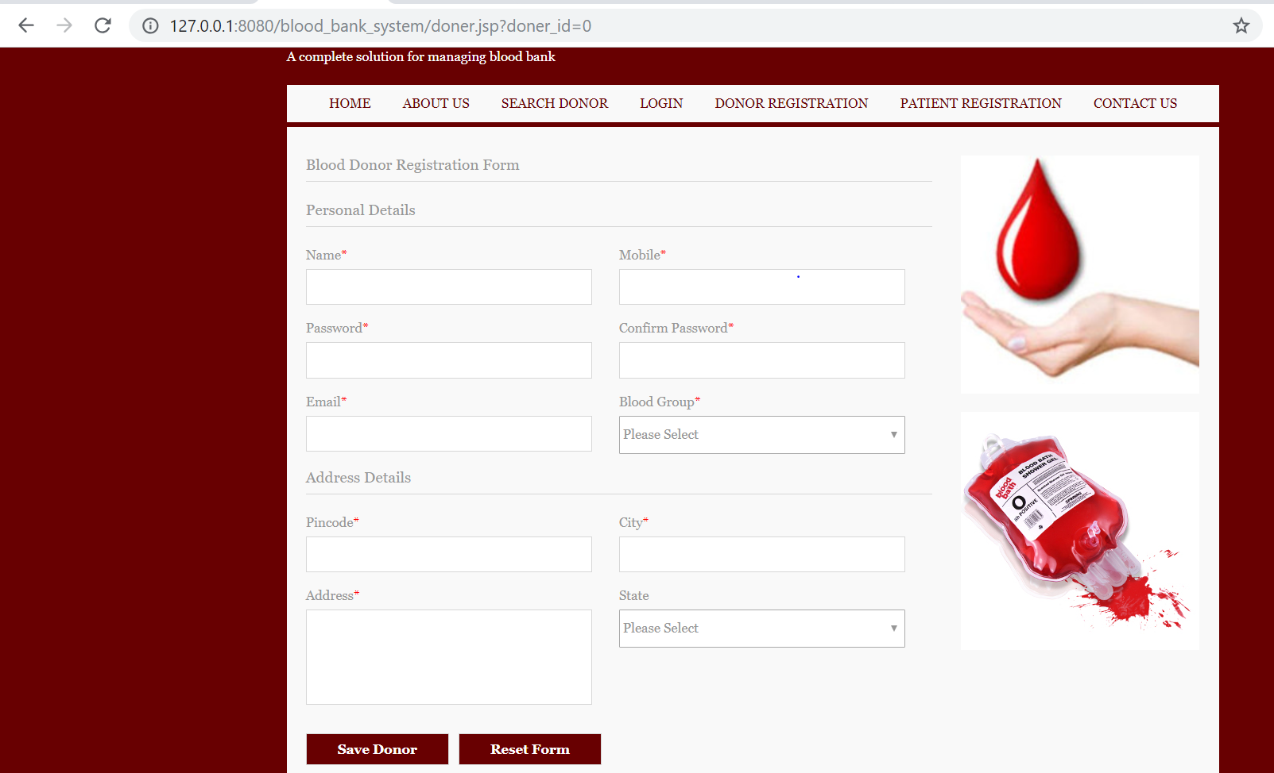

Fig: Donor Registration Form.

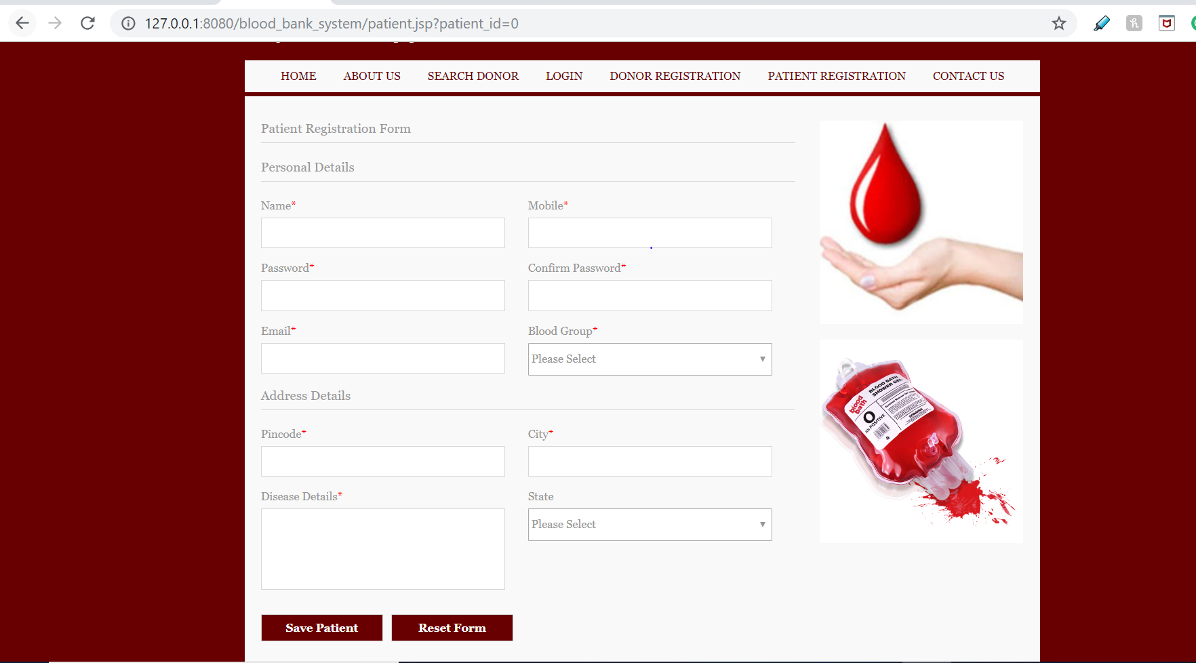

Fig: Patient Registration Form.

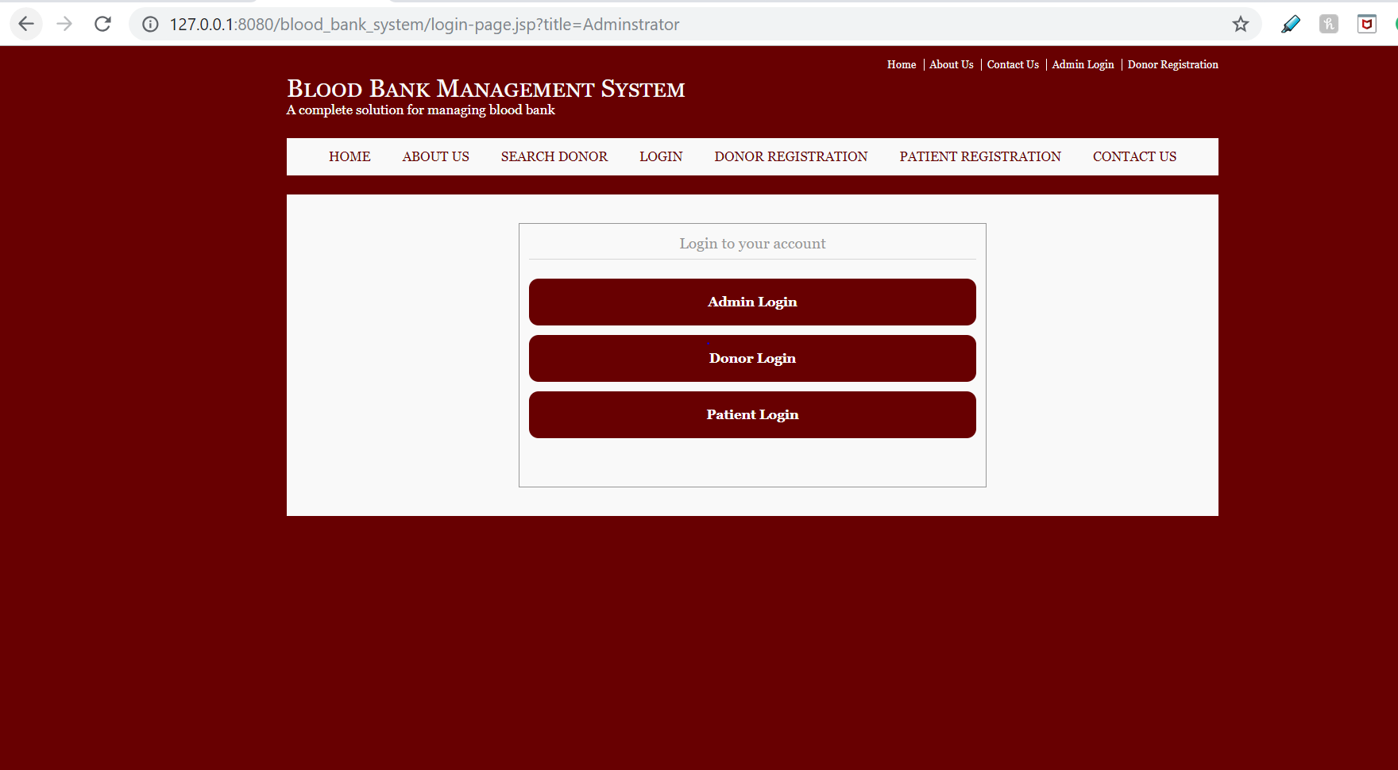

Fig: Login page for Admin/Donor/Patient

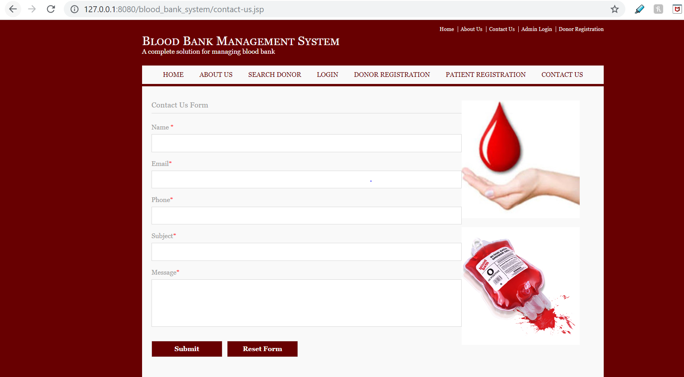

Fig: Contact Us Form

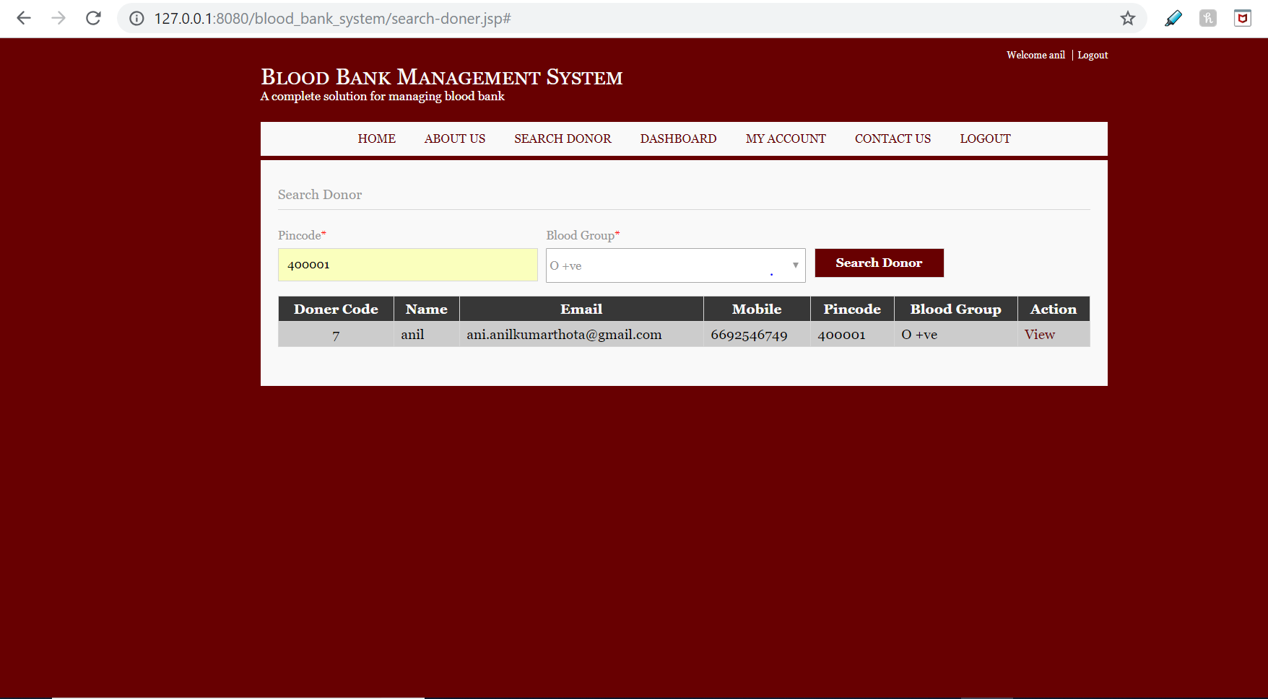

Fig: Retrieving Donor Details for Zip code and Blood Group.

Visualizations:

We used tableau for visualizations. Tableau is a Business intelligence tool for visually analyzing the data. Users can create and distribute an interactive and shareable dashboard, which depict the trends, variations, and density of the data in the form of graphs and charts. Tableau can connect to files, relational and Big Data sources to acquire and process data. Some screenshots of the visualizations are given below.

A picture containing text, screenshot

Description generated with high confidence

Fig: Number of Donors for Each Blood Type

A screenshot of text

Description generated with very high confidence

Fig: Number of Donors for Each City and its Corresponding State

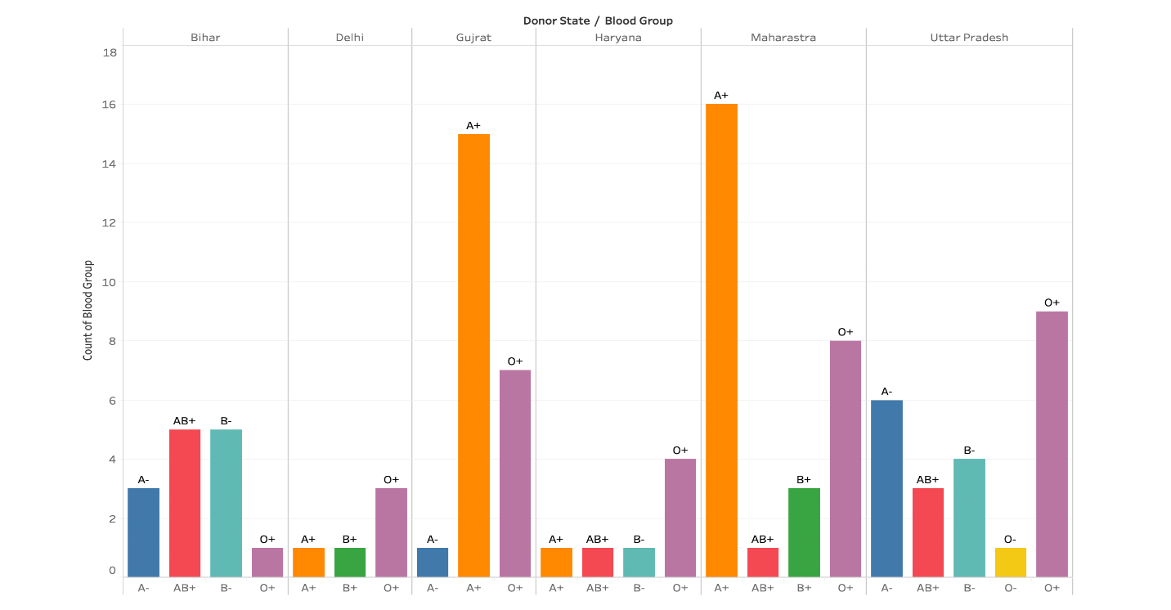

Fig: Comparing Blood Type Quantities for Each State.

A screenshot of a cell phone

Description generated with high confidence

Fig: Number of Patients for Each Blood Type

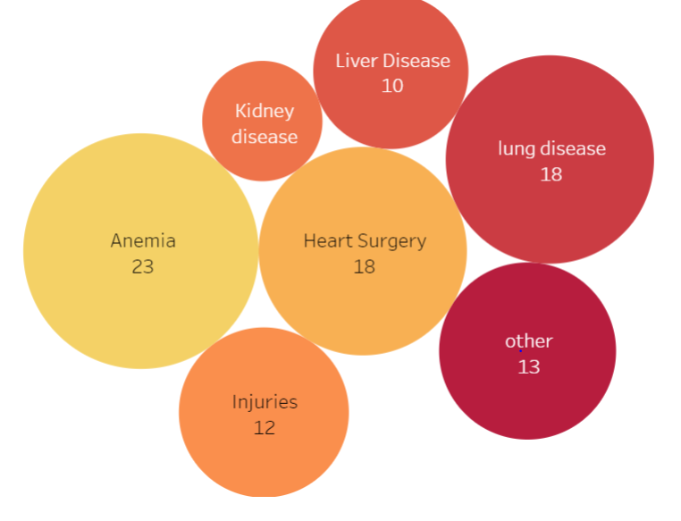

Fig: Number of Patients for Each Disease

A screenshot of a cell phone

Description generated with high confidence

Fig: Blood Quantities for Each Disease

A close up of a piece of paper

Description generated with high confidence

Fig: Number of patients for each disease for each state

Conclusion:

Overall this project gave us an ample opportunity to design , code , test and implements an application . This has helped in putting into practice of various Data Analytical principles and Database Management concepts like maintaining integrity and consistency of data. Further, this helped us to learn more about HTML, CSS and Java.

References:

* Database Systems Design Implementation & Management 13th edition text book by Carlos Coronel and Steven Morris.
* <https://www.who.int/features/qa/61/en/>
* <https://www.orlandohealth.com/blog/why-blood-donations-are-so-important>
* <https://www.brmsonline.com/blog/wellness/healthcare/2018/benefits-of-blood-donation>
* <https://www.healthline.com/health/transfusion-therapy>
* <http://www.tutorialspoint.com/>
* <https://www.w3schools.com/>